

**UNIVERSITY OF PETROLEUM & ENERGY STUDIES**

**Dehradun**

# Docker

**Experiment**

**Name: Harshil Bhardwaj**

**Course: B. TECH CSE DevOps (2018-22)**

**Roll no.: R171218045**

**Sapid: 500068580**

**Experiment- 9**

**Docker Ignore**

Create a Dockerfile and add the following code:

FROM alpine

ADD . /app

COPY cmd.sh /cmd.sh

CMD ["sh", "-c", "/cmd.sh"]

To view this file type

$ cat Dockerfile

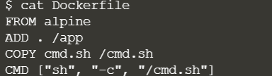

Build an image named password

$ docker build –t password.

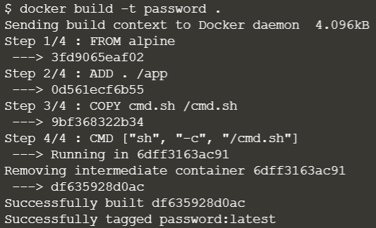

Look at the output using

$ docker run password ls /app

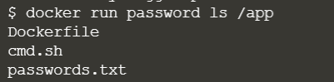

To ignore a file we name that file in .dockerignore.

Now to ignore a file let say ‘password.txt’

$ echo passwords.txt >> .dockerignore



Build the image, because of the Docker Ignore file it shouldn't include the passwords file.

$ docker built –t nopassword .

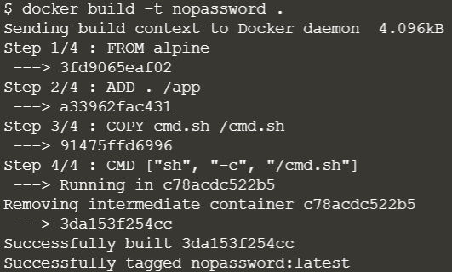

Look at the output using

$ docker run nopassword ls /app

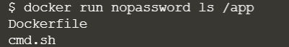

You can see a 100M impact by executing following command

$ docker build –t large-file-context

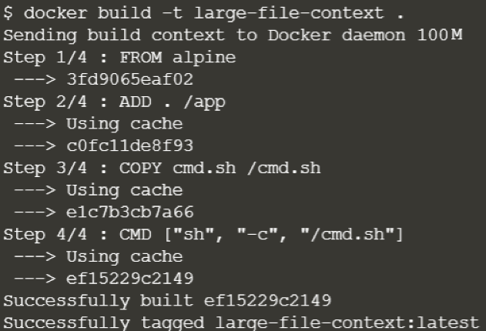

To reduce size we will ignore big file

$ echo big-temp-file.img >> .dockerignore

$ docker build –t no-large-file-context .

